October 31st 2022

FTA Communication Technologies S.à r.l.
17 Route de Luxembourg
Gonderange L-6182
Luxembourg

Declaration of Conformity

To whom it may concern,
We, FTA Communication Technologies S.à r.l., hereby declare that the following LNB products:

Brand: Inverto

Item#/Model/Description:

5597 IDLO-SNS411-OOPRO-OPN Universal Single 40mm PLL LNB
5598 IDLO-TWS411-OOPRO-OPN Universal Twin 40mm PLL LNB
5599 IDLO-QDS411-OOPRO-OPN Universal Quad 40mm PLL LNB

are in conformity with the essential provisions of:
- Electrical Equipment (Safety) Regulations 2016
- Electromagnetic Compatibility Regulations 2016
- Radio Equipment Regulations 2017
- Restriction of the Use of Certain Hazardous Substances in Electrical and Electronic Equipment
Regulations 2012

Applied standards:
* EN 55032: 2015 [EMC - Radiated power]
* EN 55035: 2017 [EMC - Immunity from radiated fields]
* EN 303372-1:v1.1.1. [RES - Satellite broadcast equipment, Outdoor unit]
* EN 62368-1:2014+A11:2017 [Safety]

Luxembourg, October 31st, 2022
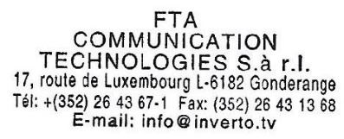
Gil Laifer,
VP of Product

