January 21st 2019

FTA Communication Technologies S.à r.l.
18 Duchscherstrooss,
Wecker 6868
Luxembourg

Declaration of Conformity

To whom it may concern,
We, FTA Communication Technologies S.à r.l., hereby declare that the following LNB product:

Brand: Inverto

Item#/Model/Description:
5597 IDLO-SNS411-OOPRO-OPN Universal Single 40mm PLL LNB
5598 IDLO-TWS411-OOPRO-OPN Universal Twin 40mm PLL LNB
5599 IDLO-QDS411-OOPRO-OPN Universal Quad 40mm PLL LNB

are in conformity with the essential provisions of:
Directive 2014/53/EU on Radio Equipment (RED)
Directive 2011/65/EC (RoHS II), EC Directive 1907/2006 on REACH

Applied standards:
* EN 55032: 2012 [Radiated power]
* EN 55020: 2007+A11:2011+A12:2016 [Immunity from radiated fields]
* EN 303372-1:v1.1.1. [RF Equipment Specifications]
* EN 62368-1:2014 [Safety]

RoHS and REACH Declaration
We hereby certify that FTA Communication Technology S.à r.l. products marked with the CE mark on its identification label, comply with the European RoHS Directive 2011/65/EC as well as the REACH Directive 1907/2006.

Luxembourg, January 21st, 2019
Gil Laifer,
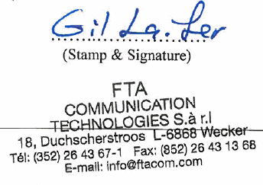
VP Product

